WEEK 4 TASK REPORT
Predictive Modeling and Optimization in Logistics Systems
Delivery-Time Forecasting Using Predictive Analytics

1. Problem Definition
This project defines a logistics forecasting problem in which shipment delivery time is predicted from shipment and transportation characteristics. The target variable is Delivery_Time_days. Forecasting delivery time can support capacity planning, customer communication, early delay identification, and transportation planning.

2. Dataset Description
The analysis uses the Week 3 hypothetical logistics dataset containing 120 shipment records. The dataset includes Region, Transport_Mode, Shipment_Volume_kg, Distance_km, Transport_Cost_INR, Delay_Days, and Delivery_Time_days. Delivery_Time_days is the prediction target.
Variable | Role | Description
Region | Feature | Geographic region
Transport_Mode | Feature | Road, Rail, or Air
Shipment_Volume_kg | Feature | Shipment weight
Distance_km | Feature | Transportation distance
Transport_Cost_INR | Feature | Estimated transportation cost
Delay_Days | Feature | Recorded delay duration
Delivery_Time_days | Target | Delivery duration to forecast

3. Model Selection
A regression approach was selected because delivery time is a continuous numerical target. Linear Regression was used as an interpretable baseline. The model estimates delivery time from encoded categorical variables and numerical logistics features. A more advanced ensemble model such as Random Forest can be added in a production extension to capture nonlinear interactions.

4. Data Preparation and Validation
Categorical variables were converted to indicator variables using one-hot encoding. The numerical variables were retained as quantitative predictors. The dataset was divided into an 80% training set and a 20% test set using a fixed random seed for reproducibility. The test set was kept separate for final evaluation. For a production system, five-fold cross-validation and hyperparameter tuning should be applied to candidate ensemble models.

5. Model Performance
Model | MAE (days) | RMSE (days) | R²
Linear Regression | 0.915 | 1.138 | 0.605
MAE measures average absolute prediction error in days. RMSE penalizes larger errors more strongly and is useful when unusually late predictions matter operationally. R² indicates the proportion of test-set variation explained relative to a mean-only baseline.
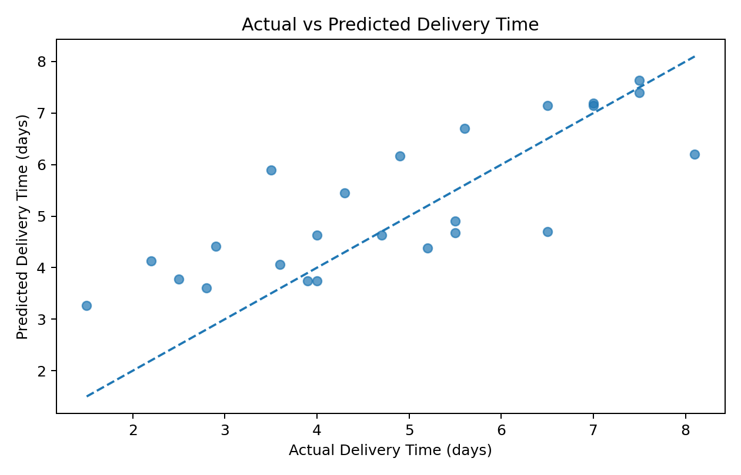
Figure 1. Actual versus predicted delivery time.
Points near the diagonal indicate smaller prediction errors. This visualization helps identify systematic under- or over-prediction.
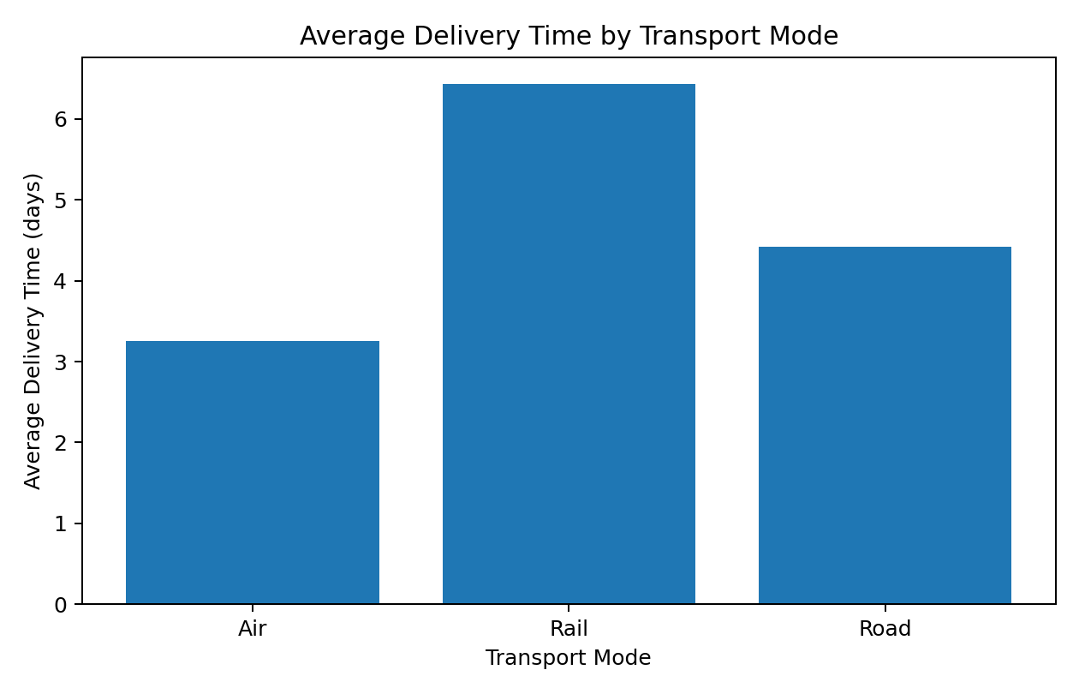
Figure 2. Average delivery time by transportation mode.
The chart compares service duration across Road, Rail, and Air and can support mode-level planning discussions.
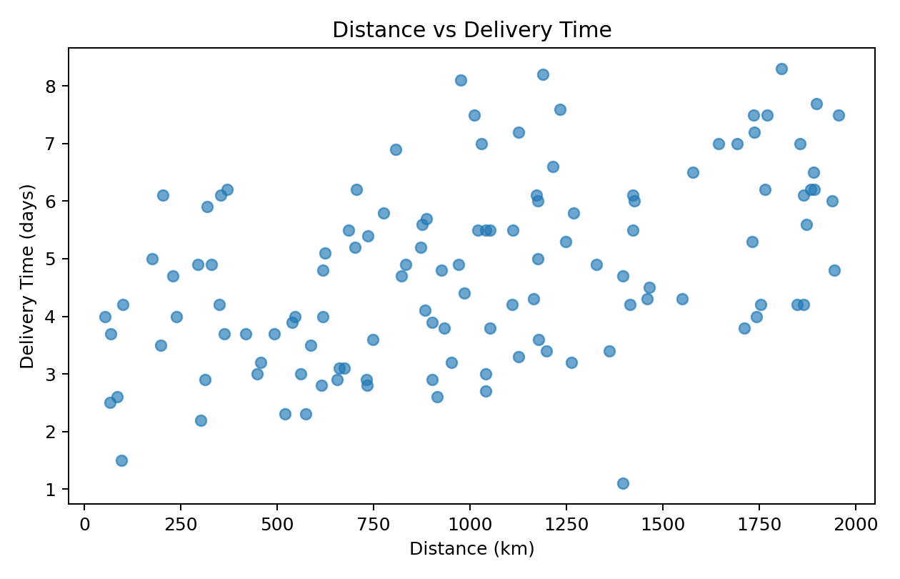
Figure 3. Distance versus delivery time.
The scatter plot helps assess whether longer transportation distances are associated with longer delivery times.

6. Python Code Snippet
import pandas as pd
from sklearn.model_selection import train_test_split
from sklearn.linear_model import LinearRegression
from sklearn.metrics import mean_absolute_error, mean_squared_error, r2_score
df = pd.read_csv("hypothetical_logistics_dataset.csv")
X = pd.get_dummies(
df[["Region", "Transport_Mode", "Shipment_Volume_kg",
"Distance_km", "Transport_Cost_INR", "Delay_Days"]],
drop_first=True
)
y = df["Delivery_Time_days"]
X_train, X_test, y_train, y_test = train_test_split(
X, y, test_size=0.20, random_state=42
)
model = LinearRegression()
model.fit(X_train, y_train)
pred = model.predict(X_test)
mae = mean_absolute_error(y_test, pred)
rmse = mean_squared_error(y_test, pred) ** 0.5
r2 = r2_score(y_test, pred)

7. Optimization Strategies
- Risk-based expediting: identify shipments whose predicted delivery time exceeds the service threshold and consider faster transportation.
- Capacity allocation: reserve additional capacity for shipments with high predicted delivery times or delay risk.
- Transport-mode planning: compare predicted delivery time against incremental transportation cost before changing modes.
- Regional bottleneck management: use predicted delays to prioritize operational attention in regions with recurring service issues.
- Cost-aware planning: formulate route and mode selection as an optimization problem that minimizes cost subject to delivery-time and capacity constraints.

8. Recommended Optimization Workflow
A practical workflow is: (1) generate delivery-time predictions, (2) flag shipments above a chosen service threshold, (3) evaluate alternative modes or routes, (4) apply capacity and cost constraints, (5) select feasible actions, and (6) monitor actual outcomes against predictions. This turns the predictive model into a decision-support tool rather than using predictions in isolation.

9. Key Insights
- The test-set MAE is 0.915 days, indicating the average absolute difference between predicted and actual delivery time in this simulation.
- The test-set RMSE is 1.138 days; comparing it with MAE helps assess the effect of larger prediction errors.
- The test-set R² is 0.605. This value describes model fit for this simulated dataset and should not be treated as a real-world performance guarantee.
- Distance, transportation mode, shipment volume, cost, and delay information can jointly support delivery-time forecasting.
- Operational optimization should consider service targets, capacity, and cost together rather than optimizing a single metric.

10. Recommendations
- Use predictive alerts to identify shipments that may miss delivery targets.
- Evaluate faster transport only when the expected service improvement justifies the incremental cost.
- Collect additional real-world variables such as route, warehouse processing time, traffic, weather, carrier, and seasonality.
- Use cross-validation and hyperparameter tuning when comparing more advanced models such as Random Forest or Gradient Boosting.
- Monitor model error by region and transport mode to detect segments where the model performs poorly.
- Back-test optimization rules on historical data before deploying them operationally.

11. Conclusion
This Week 4 project demonstrates a complete predictive-modeling workflow for logistics delivery-time forecasting. A regression model was trained and evaluated using MAE, RMSE, and R², with a clear separation between training and testing data. The predicted delivery times can be used as inputs to capacity allocation, transport-mode selection, delay-risk management, and cost-aware optimization. Because the dataset is hypothetical, the numerical results are intended to demonstrate the analytical method rather than represent actual logistics performance.

12. Deliverables Included
- Problem definition and target variable
- Dataset and feature description
- Model selection rationale
- Training and test methodology
- MAE, RMSE, and R² evaluation
- Embedded predictive visualizations
- Python code excerpt
- Optimization strategies and recommendations

